**Java Script Code Analysis Tools:**

1. **Plato** (https://github.com/es-analysis/plato)

Steps for installation

Go to the root folder of your project and run below command

npm install -g plato (installed globally )

npm install plato –save-dev (installed locally)

Command for Code Analysis

Below command will generate code analysis report for all js files recursively.

plato -r -d report src

(src is source directory of code and report will be generated in report folder of your project root folder)

For mode options please visit <https://github.com/es-analysis/plato>

To view the reports go to the report folder and open index.html file. Below the are sample screen shot of code analysis report for sample folder

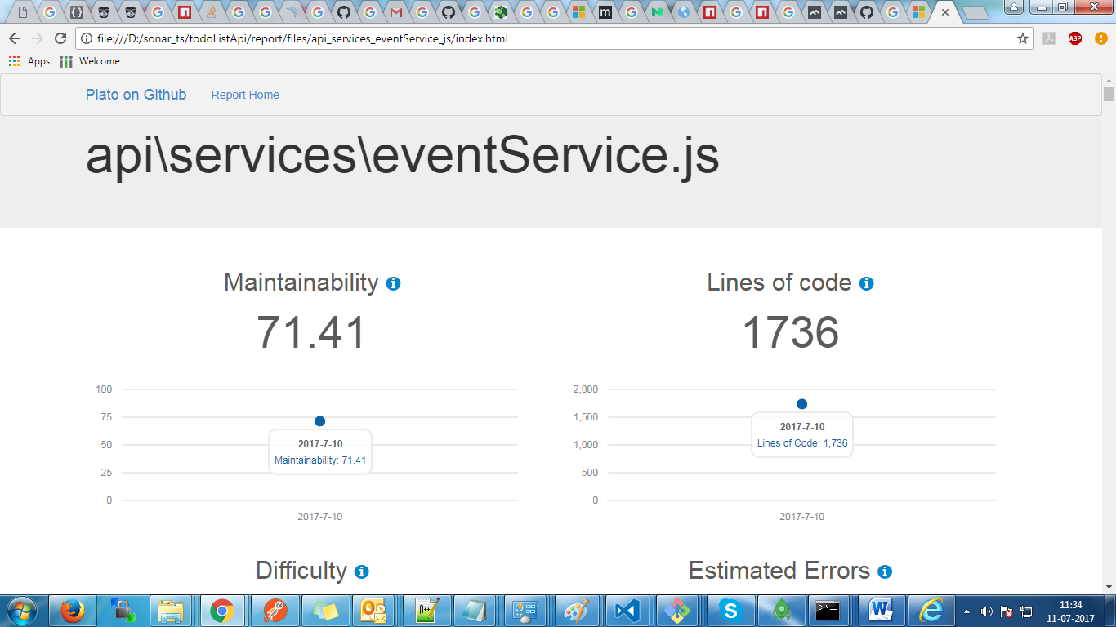

1. **Code Climate**

Code climate provide Java Script code analysis .It provide 15 days free trial for private git repository.

Steps for code analysis using code climate.

Go to the site of code climate [**https://codeclimate.com/oss/dashboard**](https://codeclimate.com/oss/dashboard)

Click on Add a repository Button

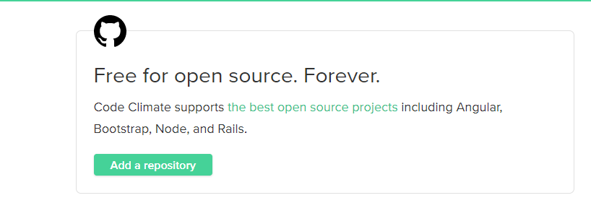

Then Given you repository link and click add repo

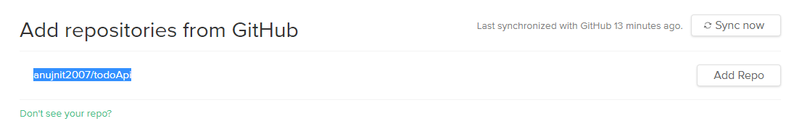

Then click sync now to do code analysis .

Then Go to Repositories and view the code analysis report

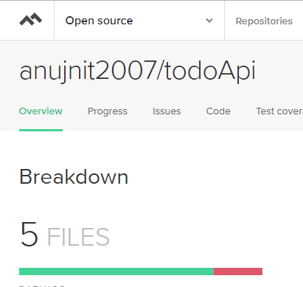

1. **Code analysis using sonar-runner**

Download the sonar server stable version and start the sonar server.

Add the **SonarJS** analyser from sonar server admin UI.

Go to Administration->System->Update Center and search SonarJS plugin.

Download the sonar-runner and add the path of bin sonar-runner to PATH variable.

path_to_ sonar-runner/bin

Go to root directory of project and run below command

sonar-runner -Dsonar.projectKey=<project_name> -Dsonar.sources=./<project_folder_name>/

Go to sonar server admin UI and see the project code analysis in projects tab.

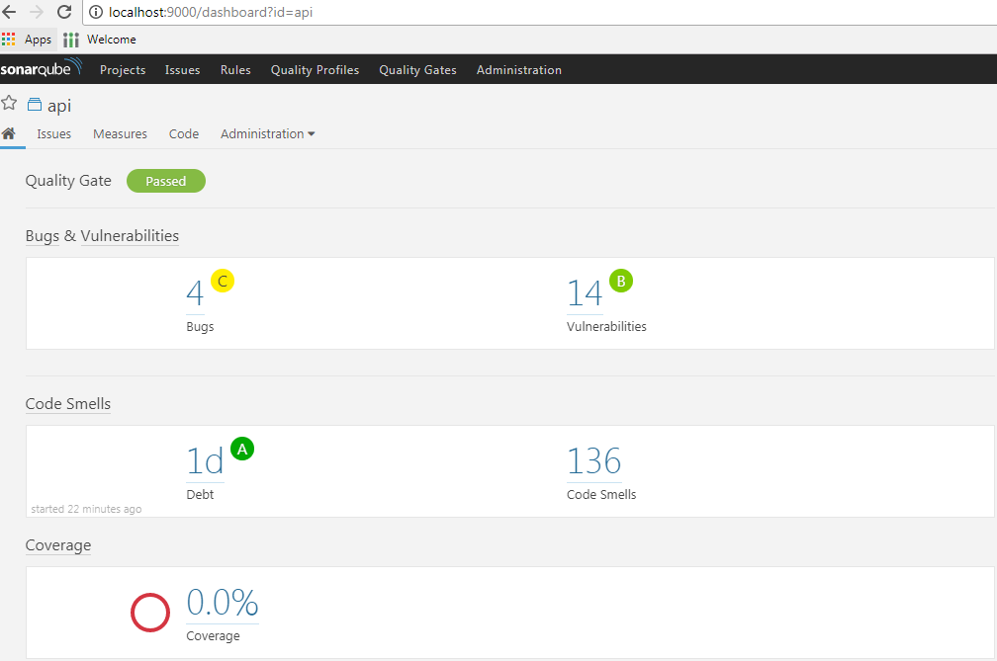

1. **Code Metrics - Visual Studio Code Extension**

It can be interesting to see the complexity of method while developing the code. Visual Studio Code has an extension **Code Metrics** to view the complexity while developing the code.

**Installation:**

Launch VS Code Quick Open (Ctrl+P), paste the following command, and press enter.

ext install vscode-codemetrics

**Commands**

Toggle code lenses for arrow functions

Toggle code metrics

They can be bound in the keybindings.json

( Go to File -> Preferences -> Keyboard Shortcuts)

{ "key": "f4", "command": "codemetrics.toggleCodeMetricsForArrowFunctions",

"when": "editorTextFocus" },

{ "key": "f5", "command": "codemetrics.toggleCodeMetricsDisplayed",

"when": "editorTextFocus" }

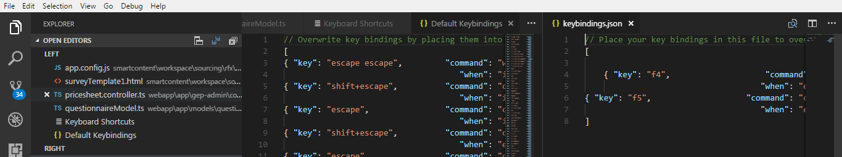

Restart the VS code and press f4 to see method complexity and f5 to code Metrix.